DIGIOTAI’S Step by step guide to

Step 1 Setting up RaspberryPi and Install Libraries

Raspberry Pi is a small computer that can use to learn programming.It supports python programming.The newer versions of RaspberryPi are supporting Windows 10 also.

RaspberryPi circuit

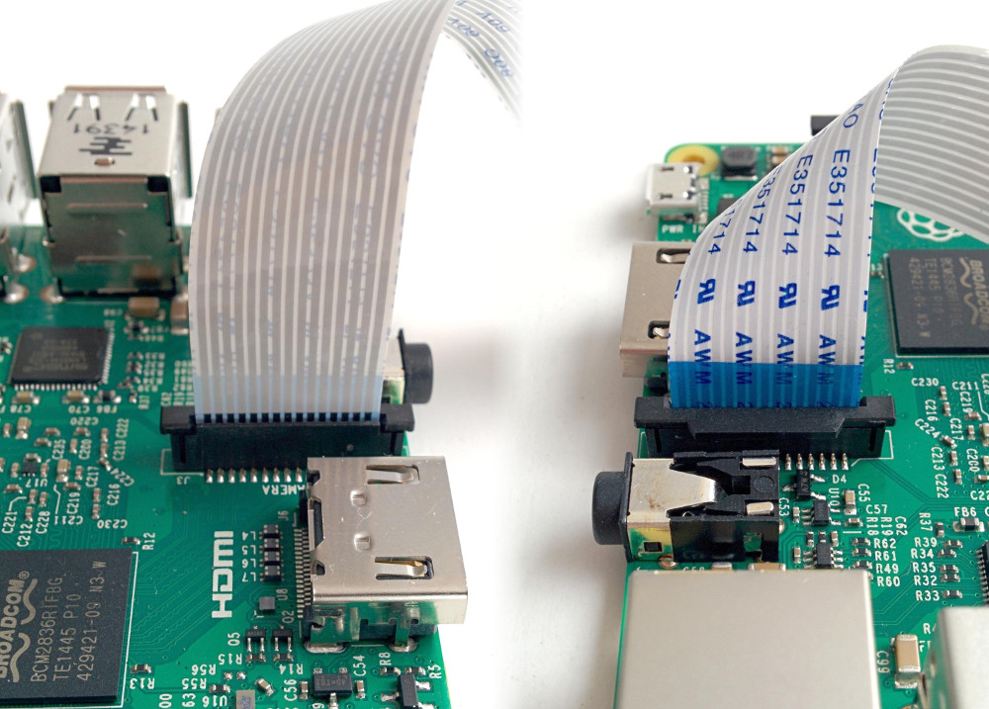

If Node.js is not installed,open the terminal and run the following commands

**$ sudo apt update**

**$ sudo apt full-upgrade**

**$ sudo apt install nodejs**

To verify installation of nodejs

**$ node -v**

**$ npm -v**

**Setting up rpivideo.py file:**

from datetime import datetime

from time import sleep

import picamera

import os

import boto3

import time

n=0

while n<5:

# camera setup

camera = picamera.PiCamera()

timestr = time.strftime("%Y%m%d-%H%M%S")

# camera warm-up time

sleep(2)

# Record Video

camera.start_recording('video'+ timestr + '.h264')

sleep(10)

camera.stop_recording()

print('video successfully recorded')

# Upload to S3 at the edge device

s3 = boto3.client('s3')

filename ='video'+ timestr + '.h264'

bucket_name = 'rpm-video-digiotai'

s3.upload_file(filename,bucket_name,filename)

print('video uploaded to aws s3')

camera.close()

sleep(1)

print (n)

n=n+1

Note: Don’t forget to change the S3 BUCKET name as per your amazon aws account

Step 2: Setting up Amazon AWS

1. Go to [console.aws.amazon.com](http://console.aws.amazon.com/) and Sign up a free account

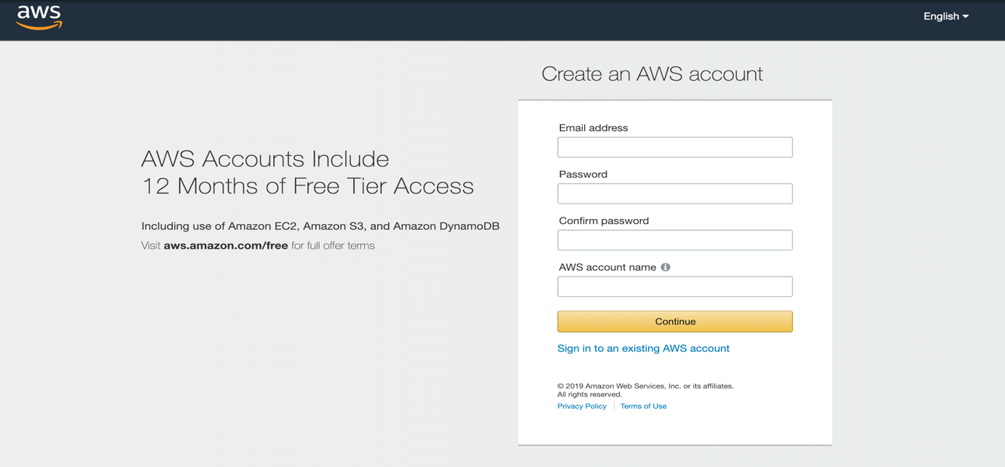

1. login to AWS Account and Create a S3 bucket in S3 Services

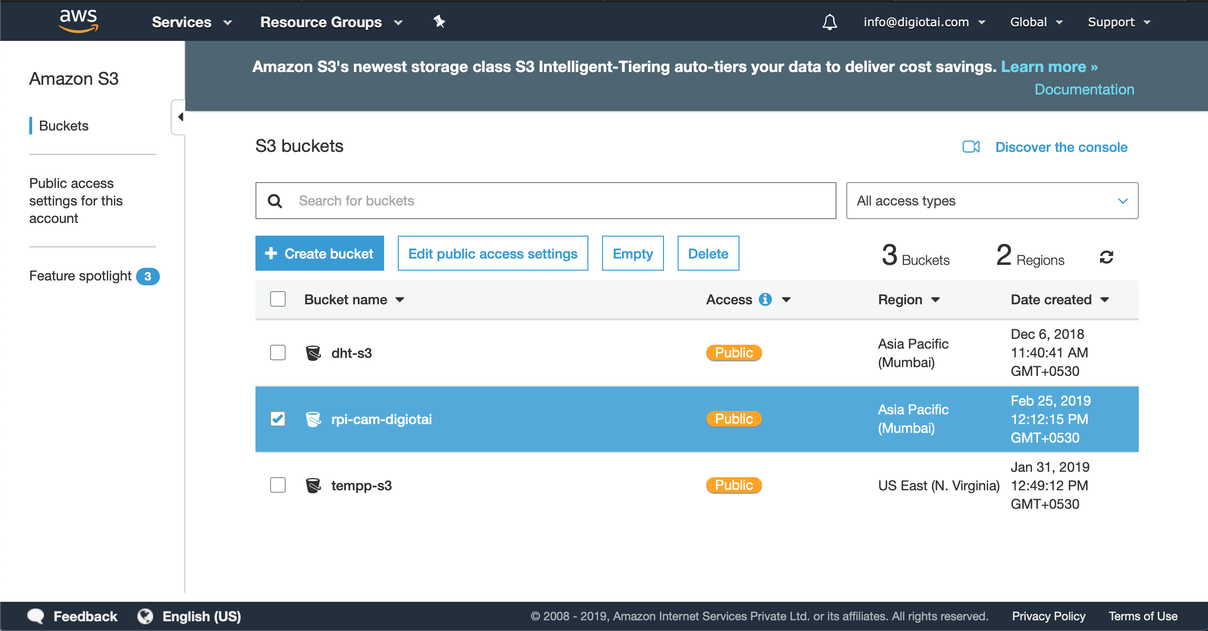

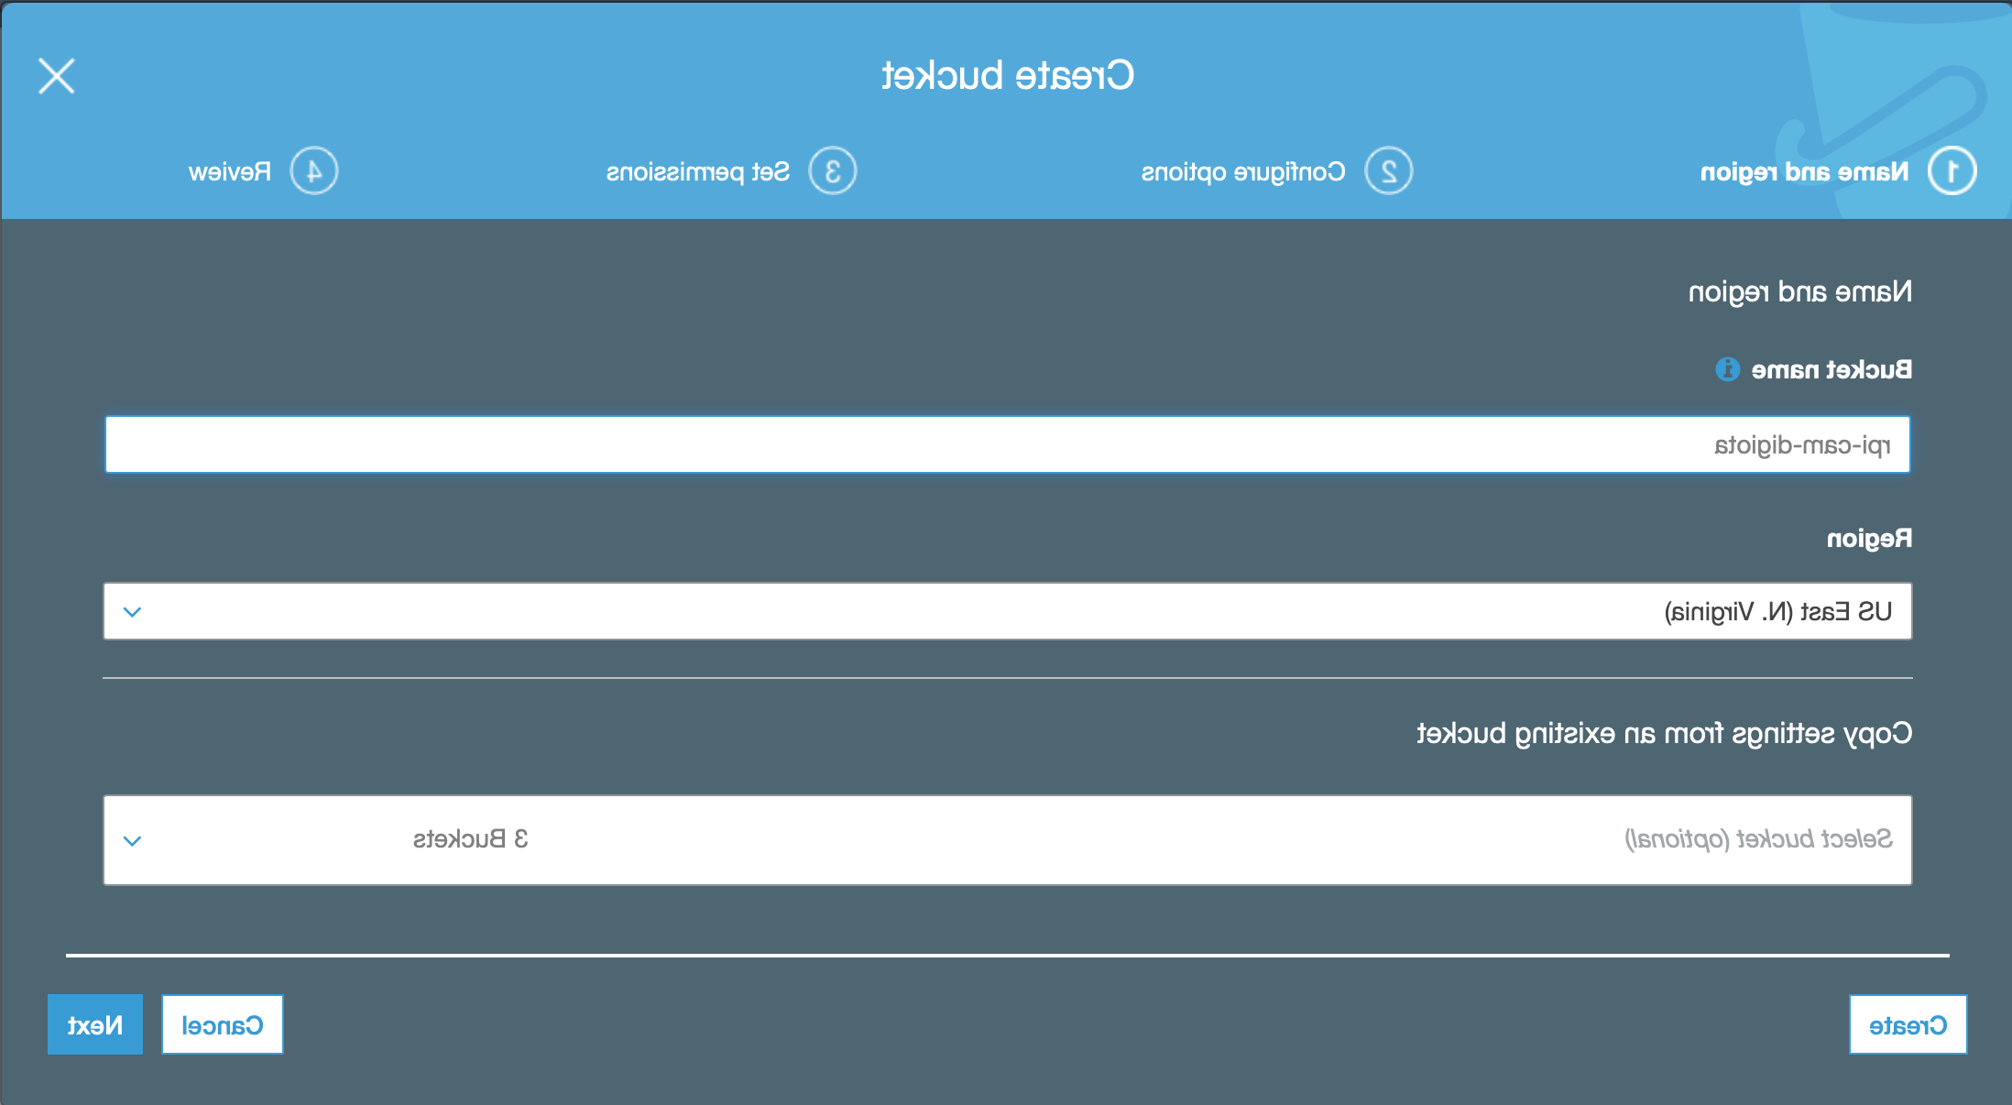

c. Type your s3 bucket name and click on next

d. click on create bucket

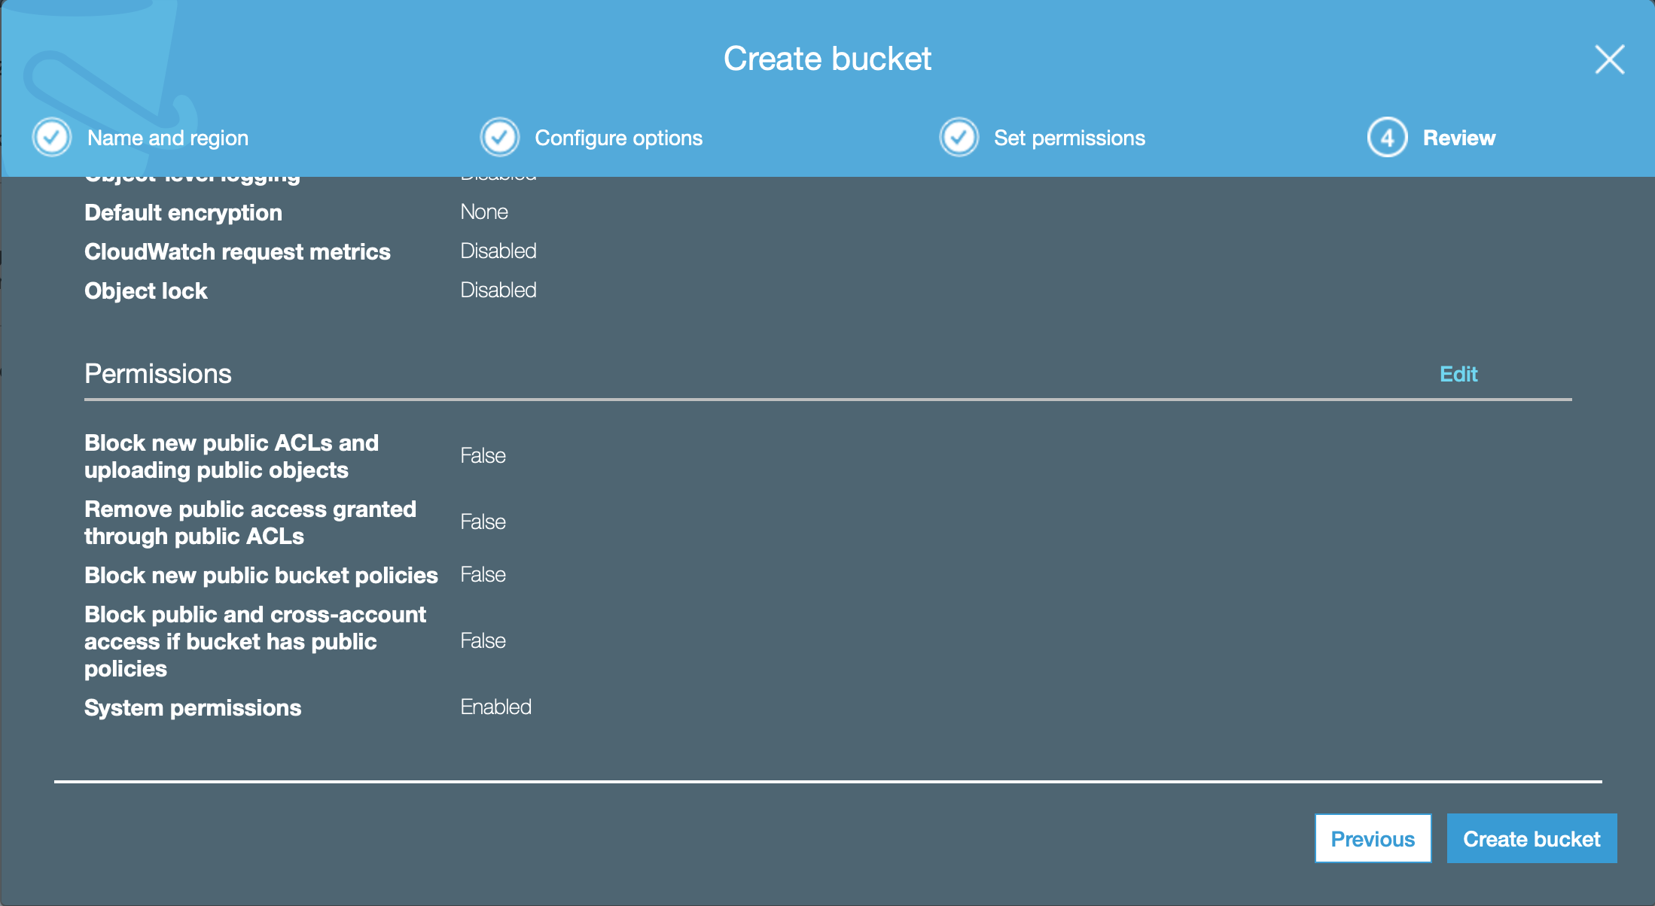

Setting up IAM Users

a. Go to IAM Services and click on users and add user

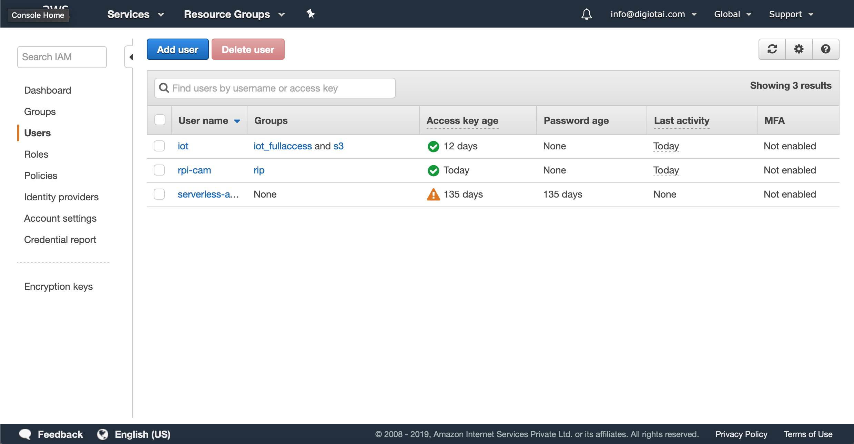

b. type your user name and click on next

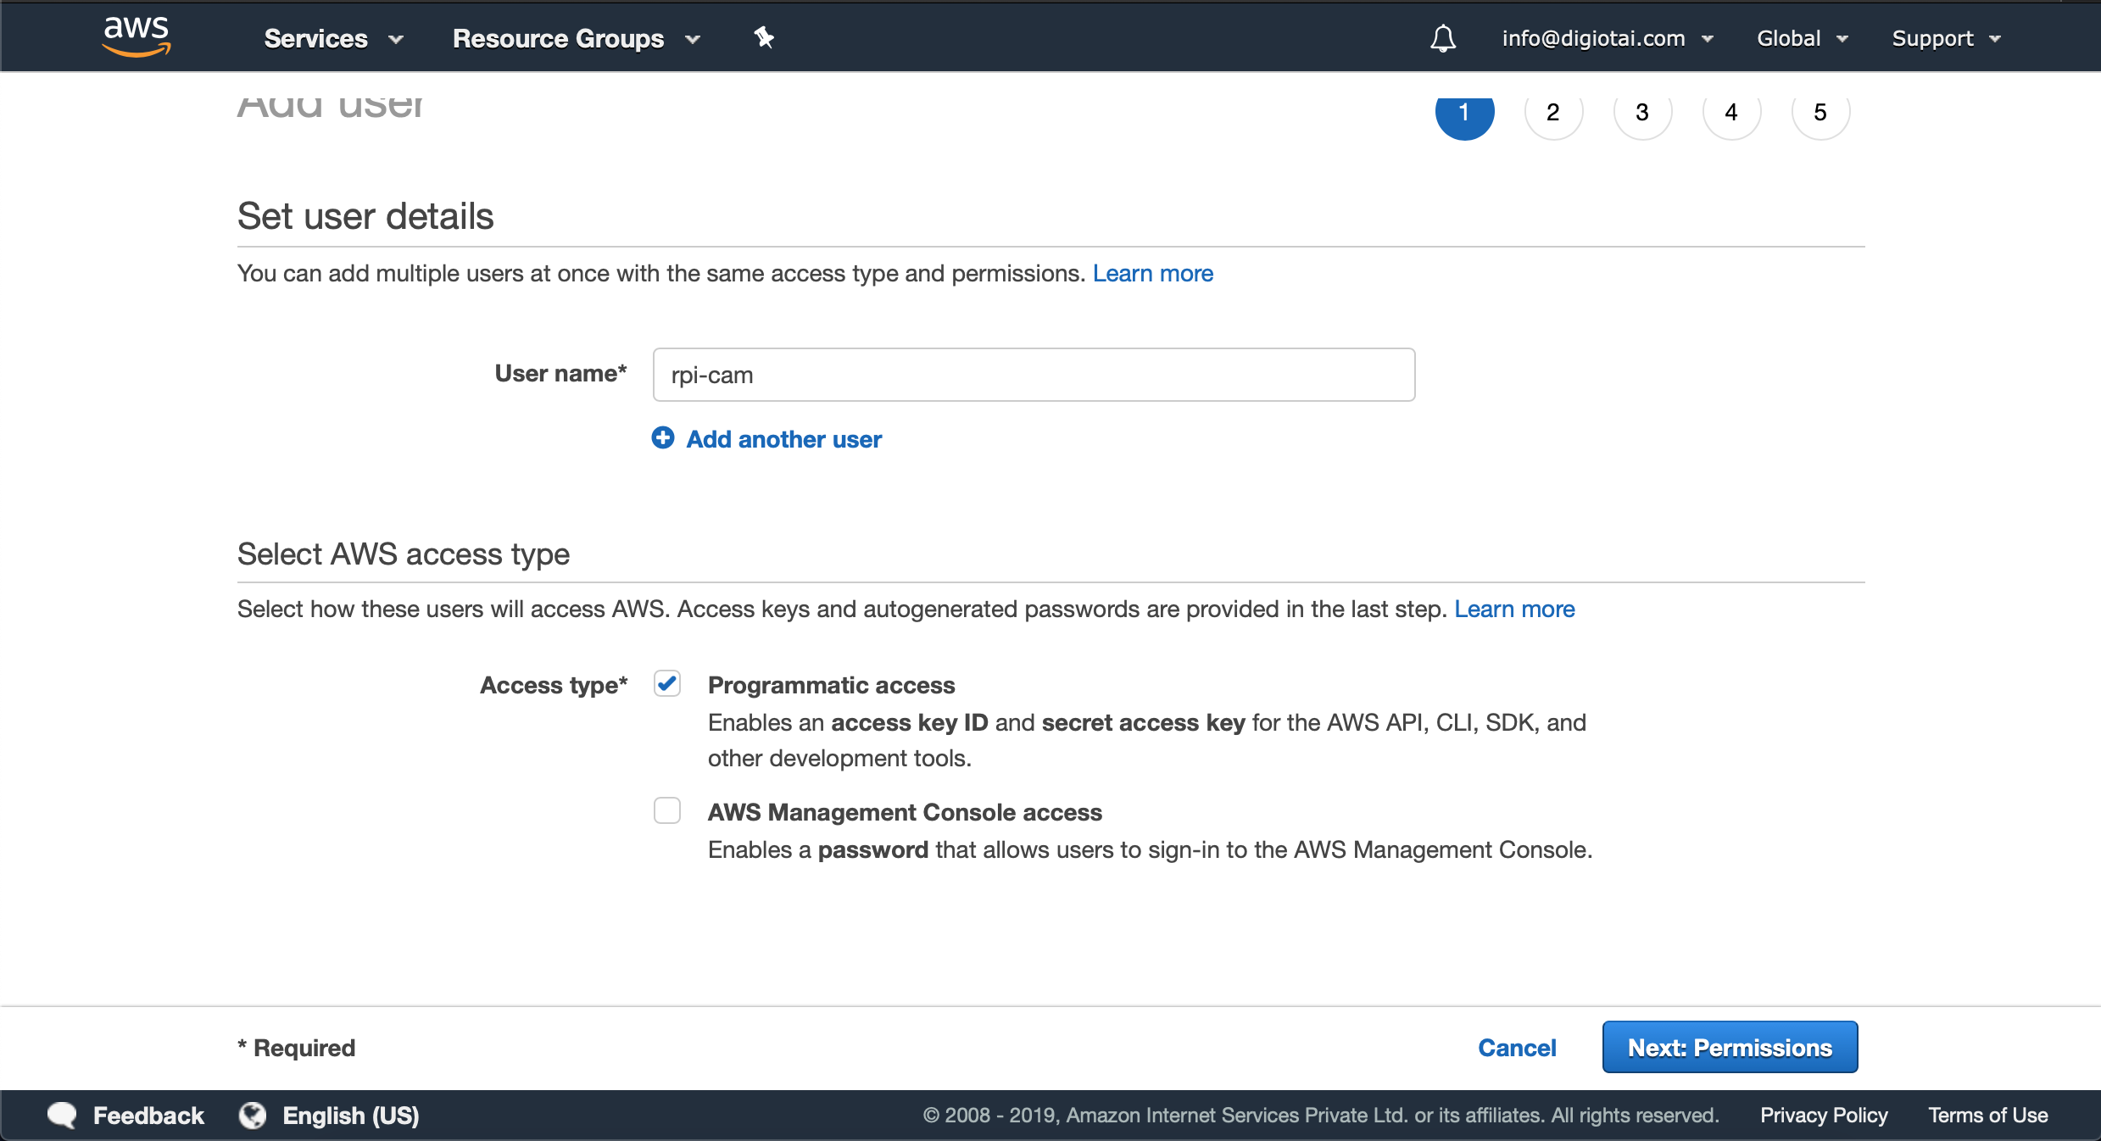

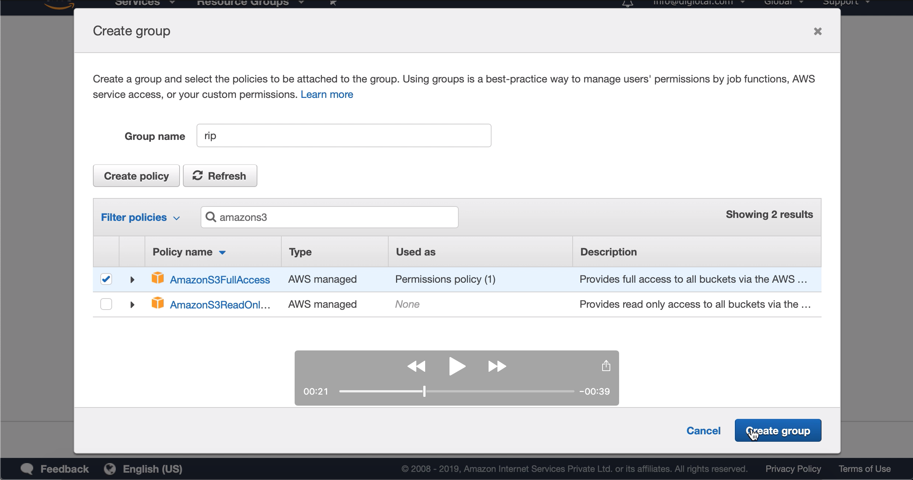c. create a group with any name as you wish and give amazons3full access and create a group

d. Assign new group to the creating user and click on create.

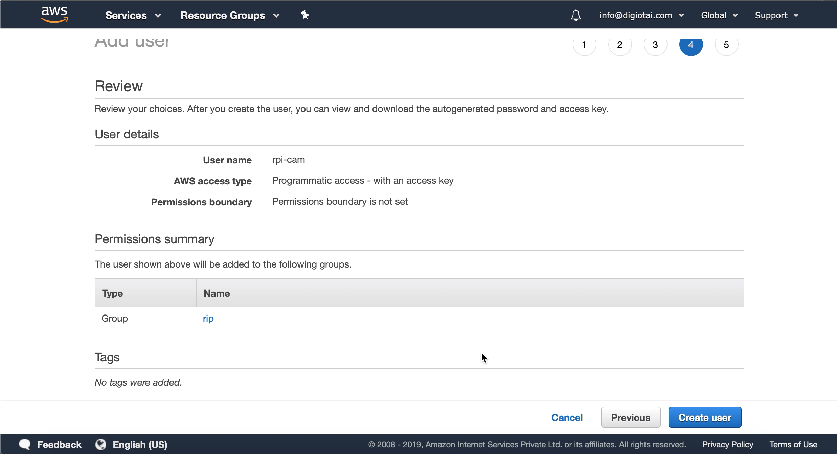

e. Save the credentials as download as .csv file

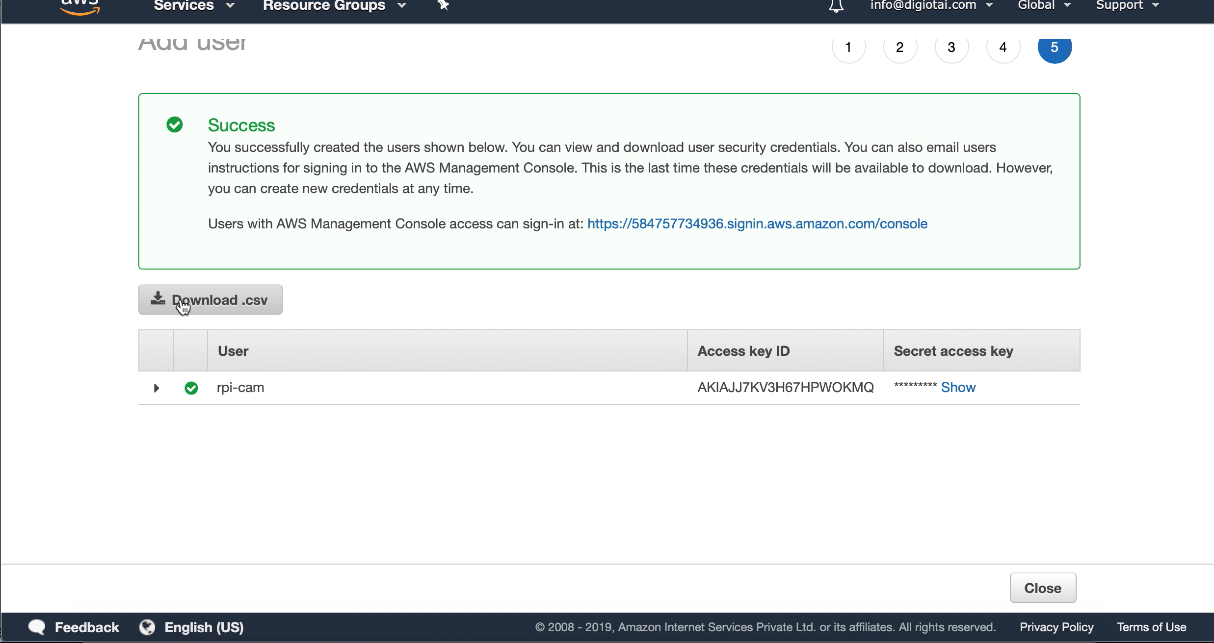

Setting AWS Account in Raspberry pi

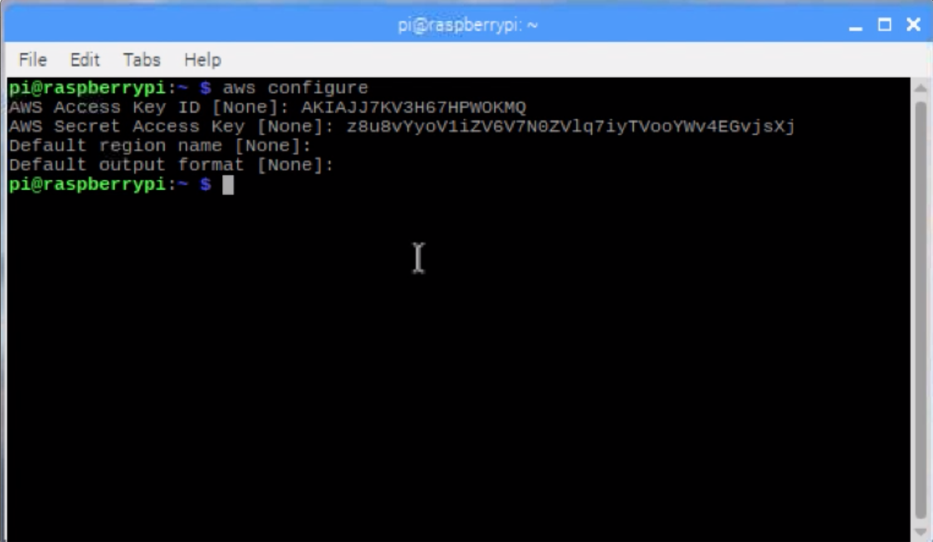a. Open terminal and type “aws configure” and paste your access id and secret code downloaded from aws as follows and leave the region and output format as default

b. type “python3 rpivideo.py” in terminal as follows

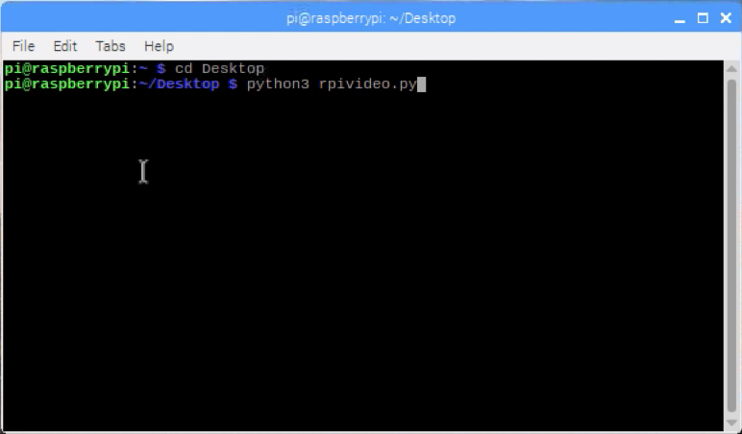

c. After executing the above command go to amazon s3 and see the output images there as follows.

